Login Page

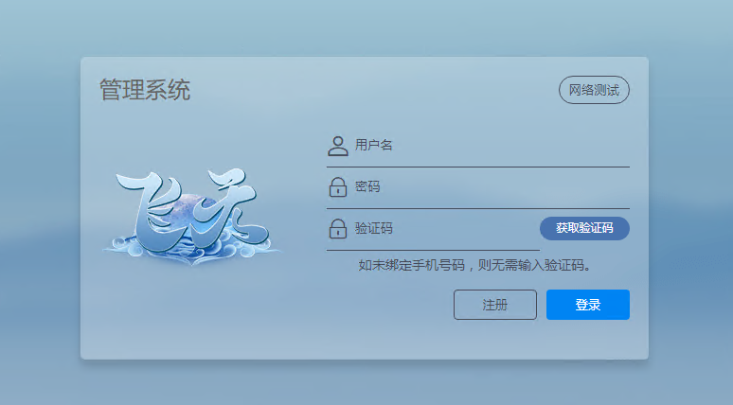 Username

Password

Network Test

Verification code

Obtaining the verification code

Login

Register

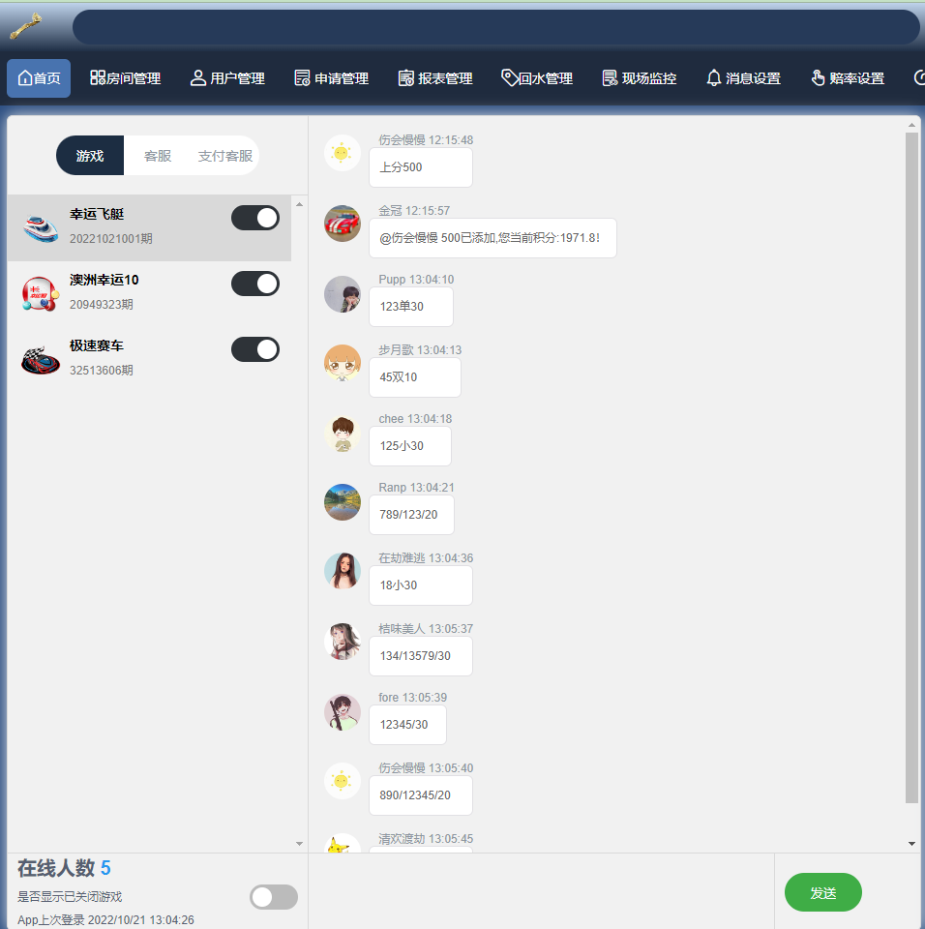Dashboard

 Select different games to monitor in real time

 For communication with users

All games for online players

send content to for sending messages

show that the game is closed

App last login

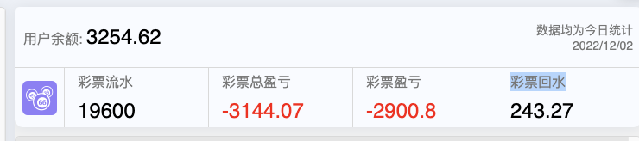

Real-time points statistics for all users

Stats on the amount wagered by all players for all games that have been opened

Win/loss statistics for all players in all games that have been opened + 回水. If a player wins away points we are negative. If a player loses points. We are positive.

Win/loss statistics for all players in all games that have been opened

回水 of the amount wagered by all gamers of all opened games

彩票总盈亏 = 彩票盈亏 + 彩票回水

|  |  |  |  |  |  |
| --- | --- | --- | --- | --- | --- |
| 游戏名称 | 开奖期数 | 本期游戏下注金额统计 | 今日游戏下注金额统计 | 今日盈亏 | 游戏开奖倒计时 |
| Game Name | Number of draws | Statistics on the amount of money wagered on this game | Today's game betting statistics | Today's Profit and Loss | Game start countdown |

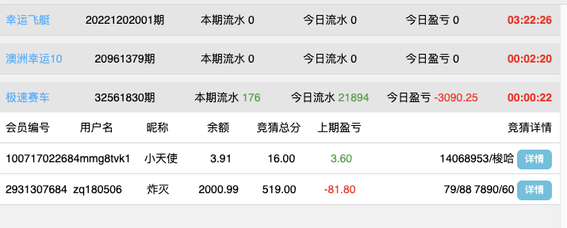

Under each game, the results of all the users who played the last round of the current game are displayed in real time (This panel is displayed when user bet)

会员编号：Unique ID generated by the system for the member (cannot be modified)  
用户名： User's login name (cannot be changed)  
昵称： User nickname (can be changed)  
余额：Remaining points for users  
竞猜总分： The total score of the user's last bet  
上期盈亏：The user's profit/loss on the previous round  
竞猜详情： Details of what the user has wagered. Click on the 详情 to see the breakdown

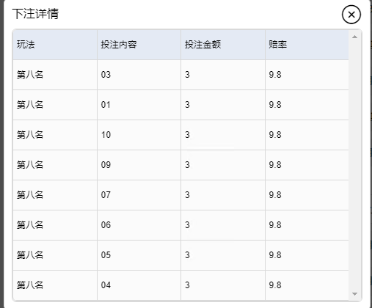

position

number

wagered point

odds

Room Management Page

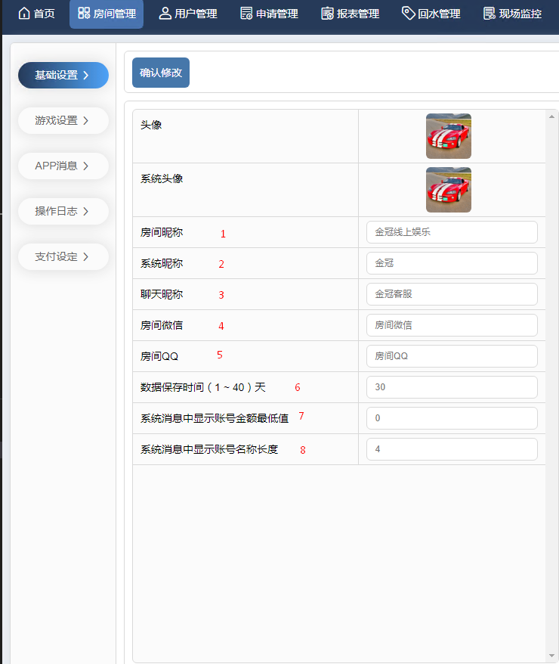Basic Setting(基础设置)

change button

robot and room manager avatar

room avatar

1. Room nickname
2. System nickname
3. Chat nickname
4. Not displayed
5. Not displayed
6. Data storage time
7. The minimum value of the account amount is displayed in the system message
8. Display account name length

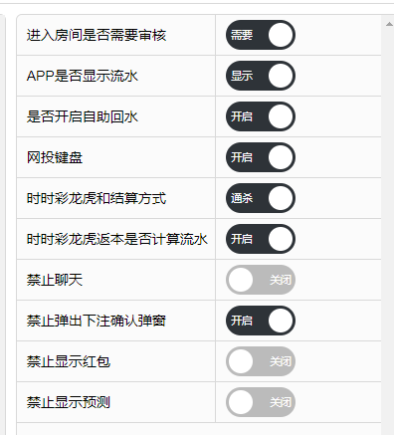Need to ask

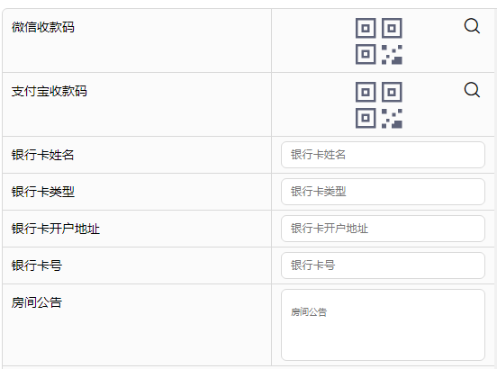WeChat payment code

Alipay payment code

Bank card name

Bank card type

Bank card account opening address

Bank card number

room announcement

game setting (房间公告)

|  |  |  |  |  |  |  |  |
| --- | --- | --- | --- | --- | --- | --- | --- |
| 序号 | 游戏名称 | 开启游戏 | 开启时间 | 关闭时间 | 定时任务状态 | 每局全部用户下注限制 | 是否允许取消注单 |
| Serial number | Game Name | Start the game | Opening time | Closing time | Timed task status | Per game User betting limits | Can the user cancel the order |

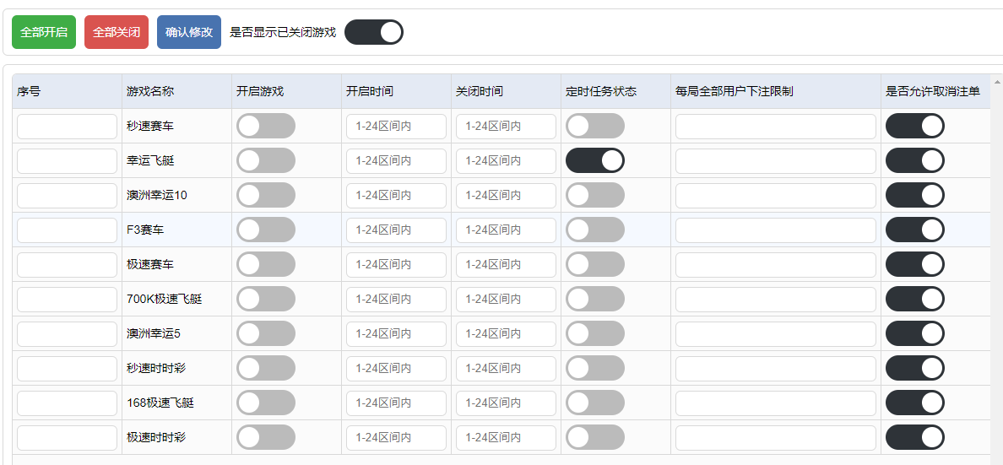

Open all close confirm modification Whether to show that the game is closed

Explain about more detail

APP消息: App message (what is this used for? Need data )

Search Empty Add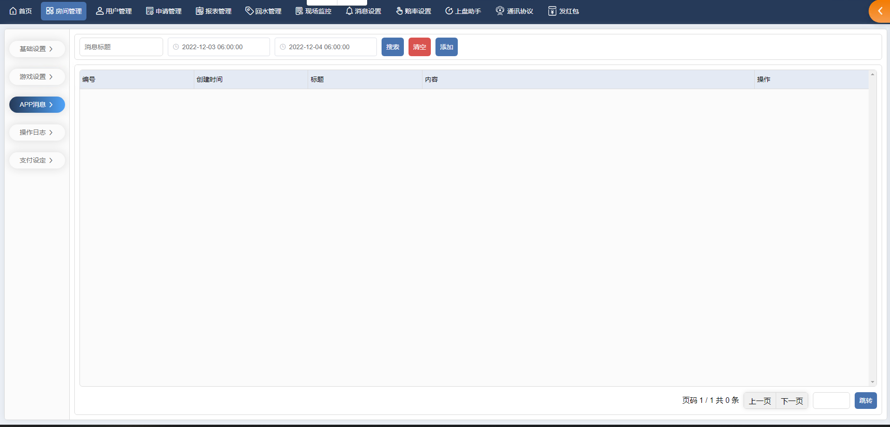

|  |  |  |  |  |
| --- | --- | --- | --- | --- |
| 编号 | 创建时间 | 标题 | 内容 | 操作 |
| Serial number | Creation time | The title | content | operation |

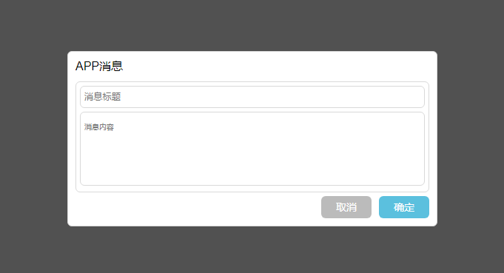

No data so explain more detail

操作日志 : operation log

登录日志：login log Search Clear

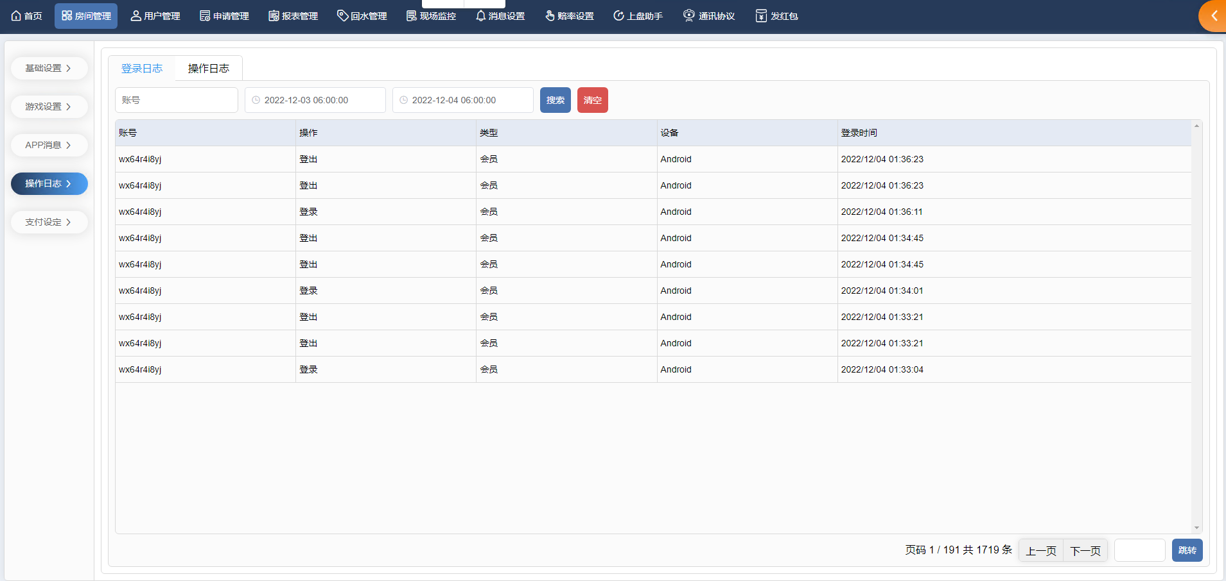

|  |  |  |  |  |
| --- | --- | --- | --- | --- |
| 账号 | 操作 | 类型 | 设备 | 登录时间 |
| Account Number | Operation | Type | Equipment | Login time |

操作日志：(Operation log)

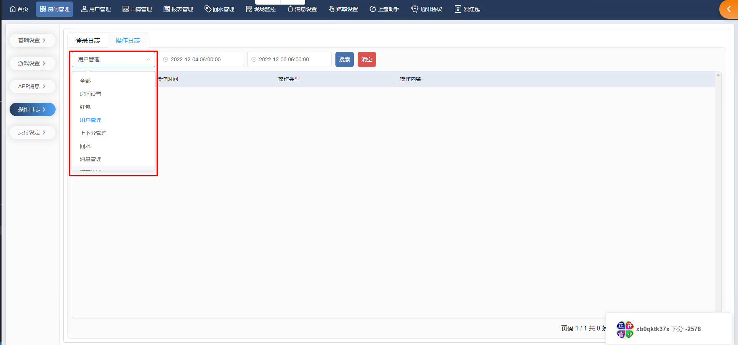

|  |  |  |  |
| --- | --- | --- | --- |
| 用户名 | 操作时间 | 操作类型 | 操作内容 |
| Username | Operation time | Type of operation | Operation content |

支付设定 payment setting New setting (Need Data)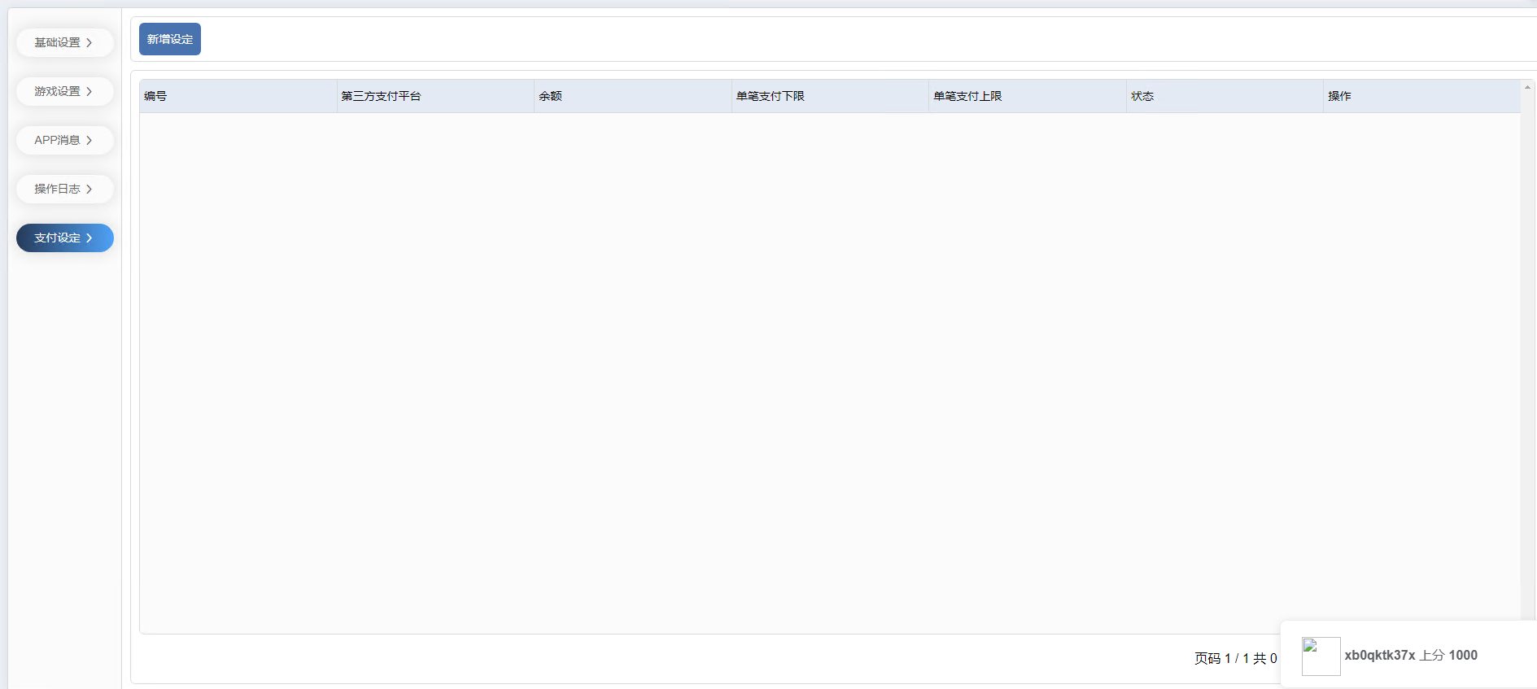

|  |  |  |  |  |  |  |
| --- | --- | --- | --- | --- | --- | --- |
| 编号 | 第三方支付平台 | 余额 | 单笔支付下限 | 单笔支付上限 | 状态 | 操作 |
| No. | Third party payment platforms | Remaining amount | Minimum amount per payment | Maximum amount per payment | Status | Operation |

用户管理 User Management

用户列表 List of users

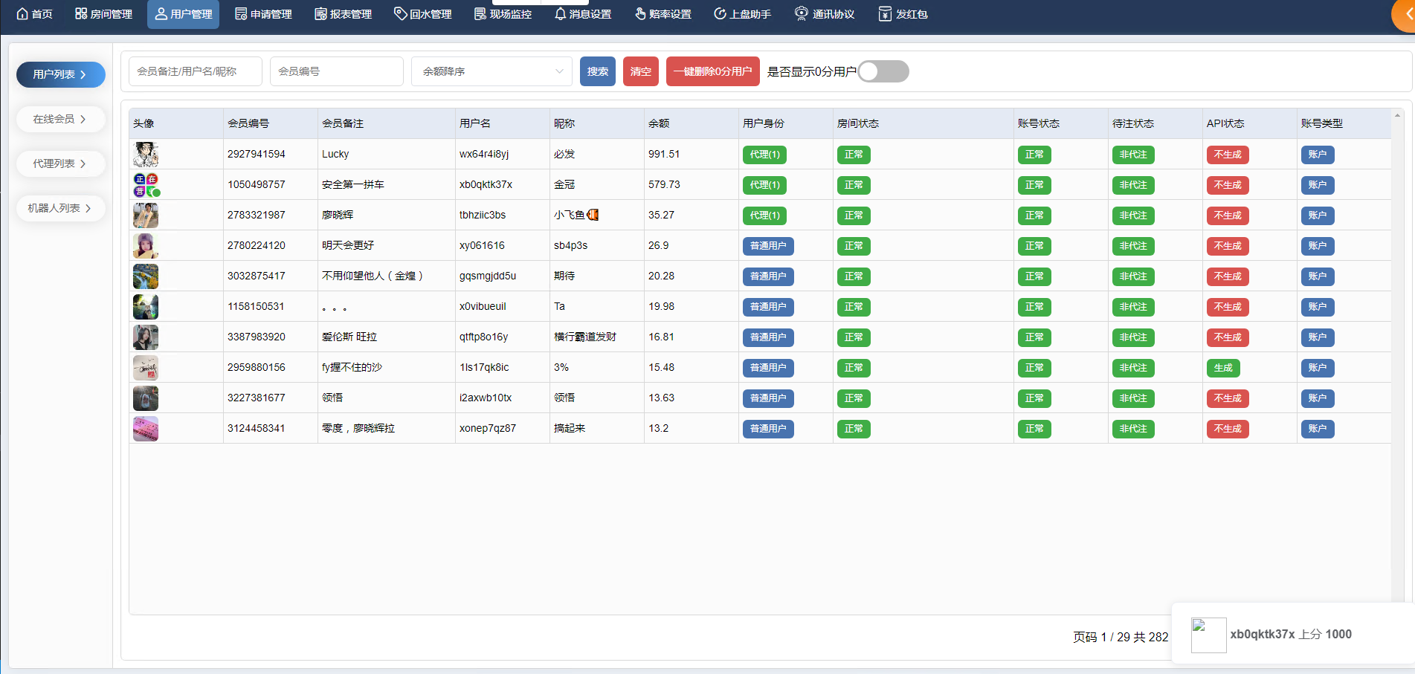

|  |  |  |  |  |  |  |  |  |  |  |  |
| --- | --- | --- | --- | --- | --- | --- | --- | --- | --- | --- | --- |
| 头像 | 会员编号 | 会员备注 | 用户名 | 昵称 | 余额 | 用户身份 | 房间状态 | 账号状态 | 待注状态 | API状态 | 账号类型 |
| Avatar | Membership Number | Notes to Members | Username | Nickname | Remaining amount | User Identity | Room Status | Account Status | Status of substitution | Api Status | Account Type |

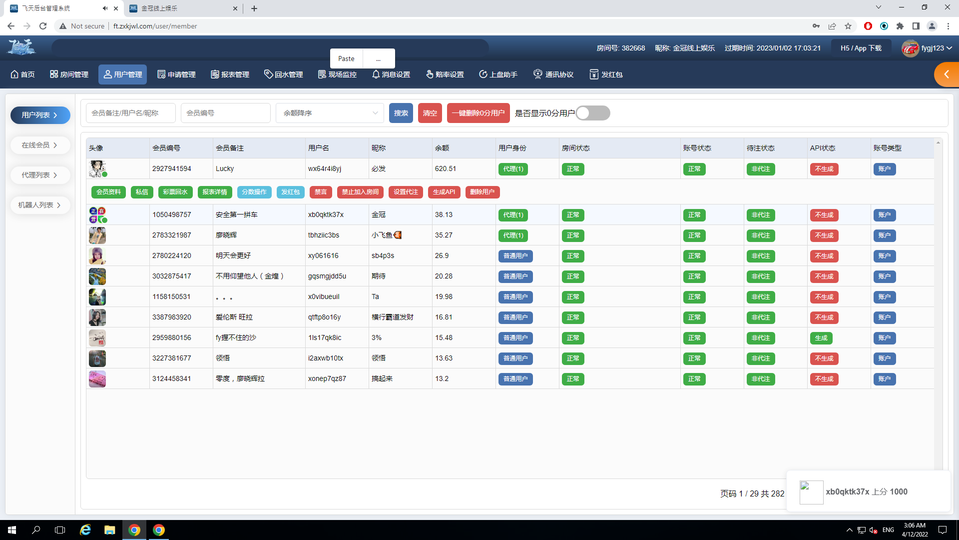

会员资料 member profile

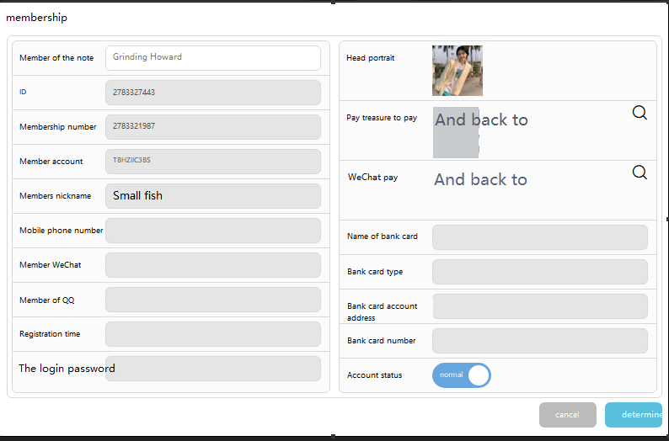

私信 Private letter

Clicking on it brings up an input box to send a message to the specified user

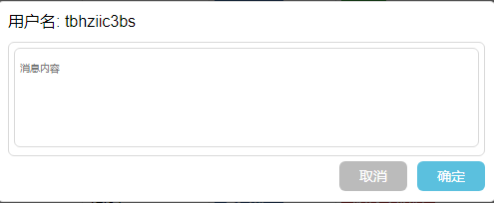

彩票回水：It is used to open the special return water, which means that the user's return water ratio is different from the normal setting

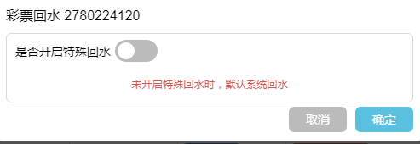 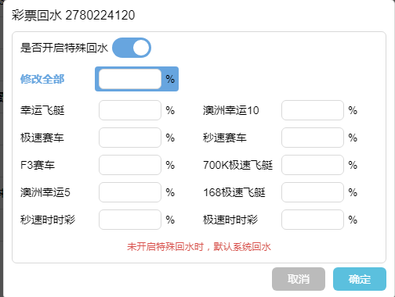

报表详情: Report Details

总报表： For viewing total user point changes

彩票报表: For viewing a user's betting history

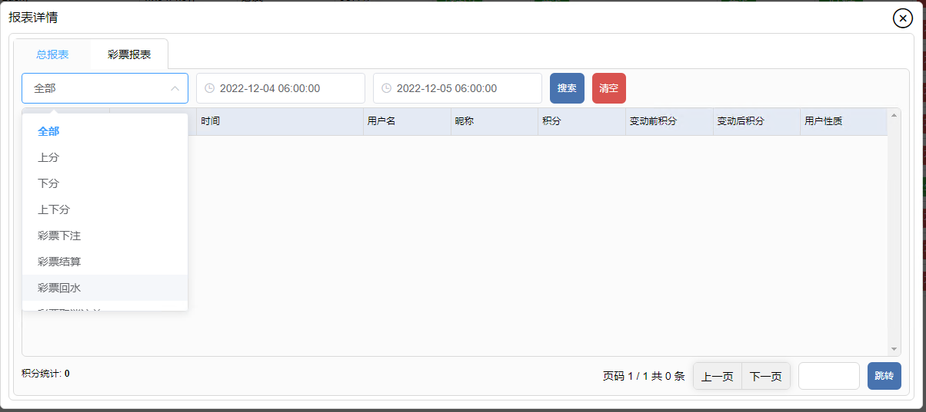

类型type

游戏The game

时间time

用户名User name

昵称 nickname

积分point

变动前积分 before point

变动后积分 after oiubt

用户性质nature of user

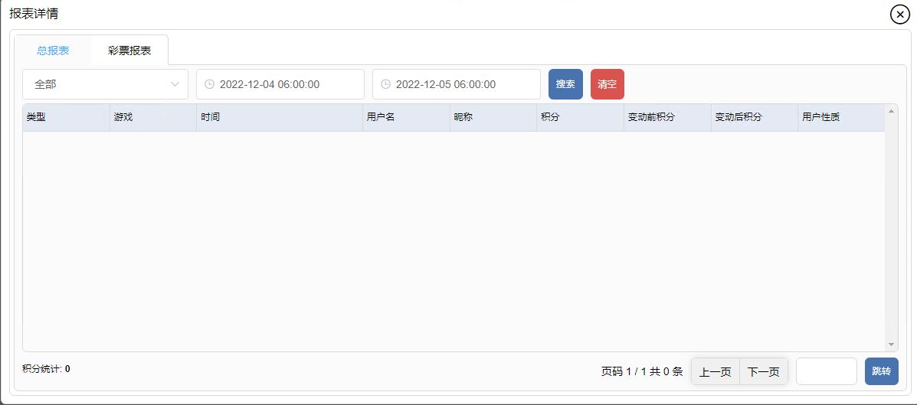

游戏 The game

期号 issue

用户名User name

玩法 play

下注内容 Content of Bets

下注金额 Amount bet

下注时间Time to bet

开奖结果 Results of the lottery

状态/輸赢Status/win/lose

分数操作： Manually add points to and remove points from users

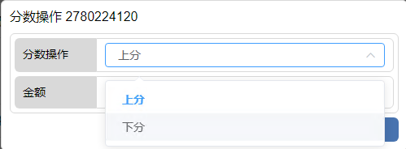

发红包(red envelope)：Manually send a bonus to the user, who can then click on the betting screen to get the bonus

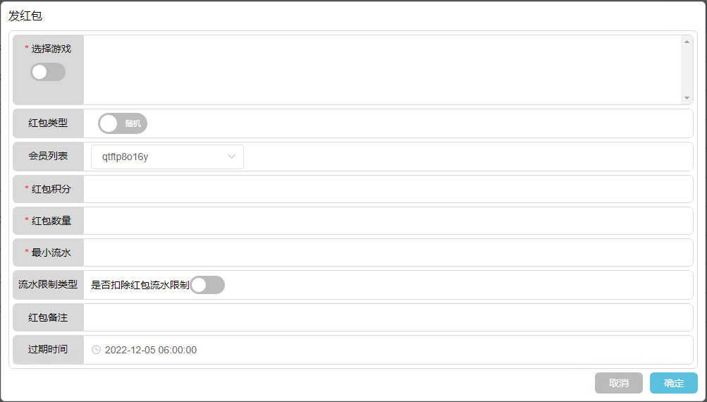

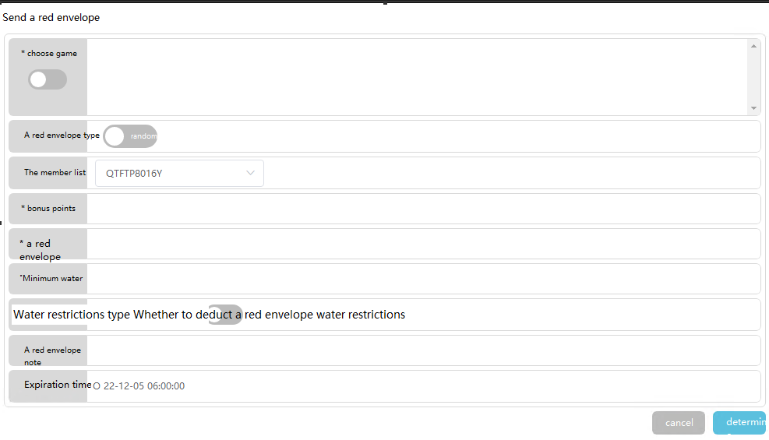

禁言: silence

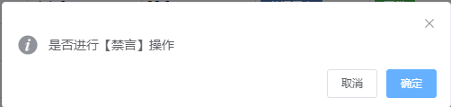

禁止加入房间: don’t join the room

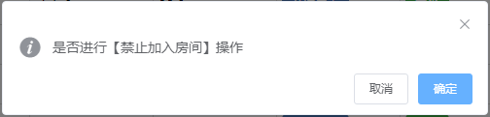

设置代理：(set proxy)

Confirm whether to generate a proxy After generating a proxy, the user will be removed from the user list and added to the proxy list

设置代注: Set the user as a bot This action will force the user offline. All of the user's games will then not generate a statement

生成 api (generate api):  此操作会复制此用户的投注内容。然后在超级管理员游戏平台生成一个账号进行投注。

删除用户: (delete user)

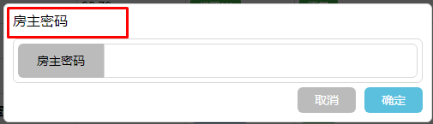

在线会员(online member)

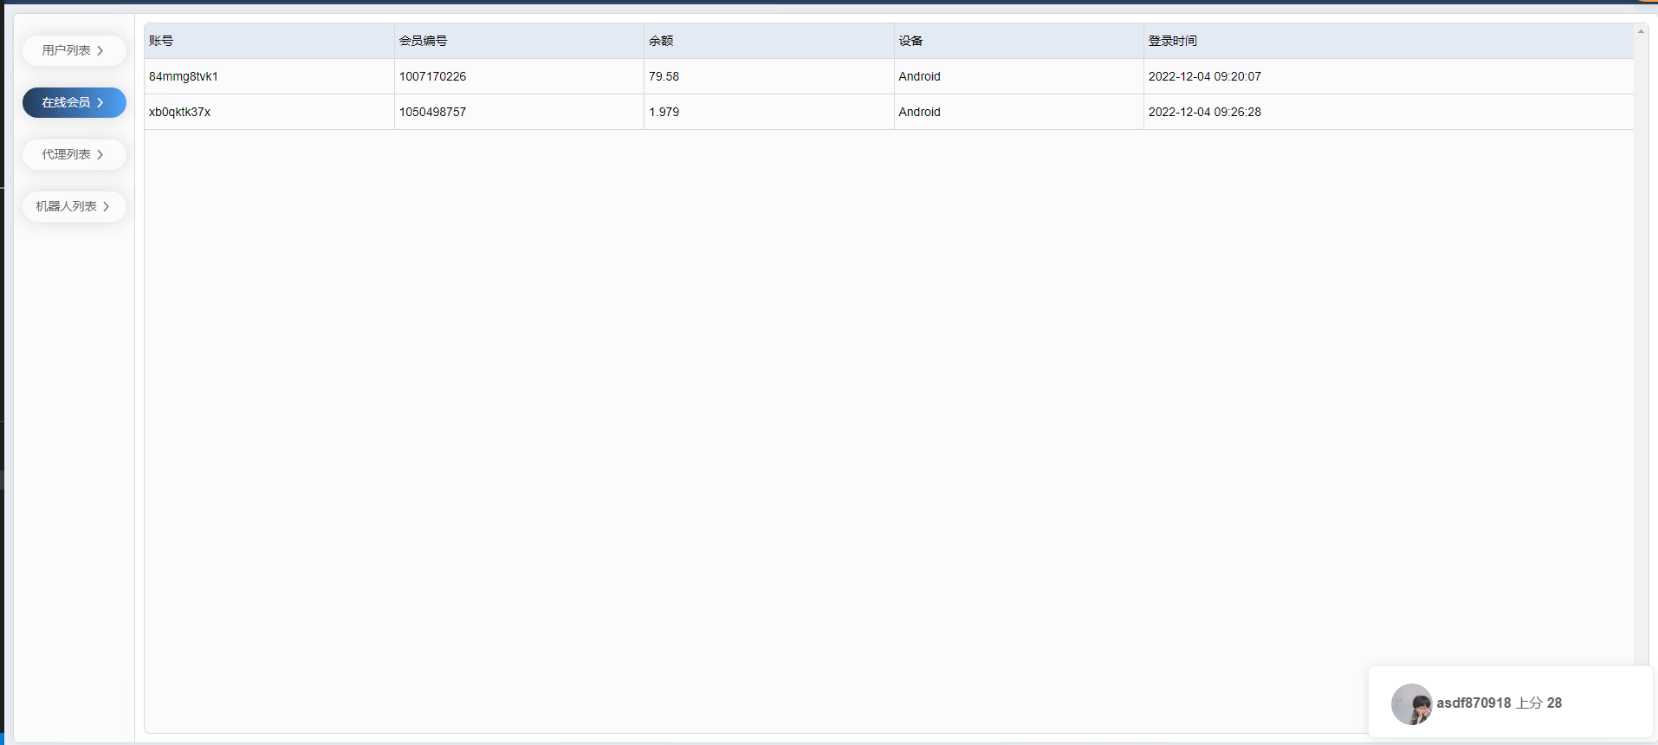

|  |  |  |  |  |
| --- | --- | --- | --- | --- |
| 账号 | 会员编号 | 余额 | 设备 | 登录时间 |
| Account Number | Membership Number | Remaining amount | Equipment | Login time |

代理列表：(proxy list)

Agents can hook up with other users to enjoy other users' betting income.

|  |  |  |  |  |  |  |  |
| --- | --- | --- | --- | --- | --- | --- | --- |
| 头像 | 用户名 | 昵称 | 会员备注 | 代理等级 | 下级代理人数 | 下线人数 | 操作 |
| Avatar | Username | Nickname | Notes to Members | Agency level | Number of subordinate agents | Number of subordinates | Operation |

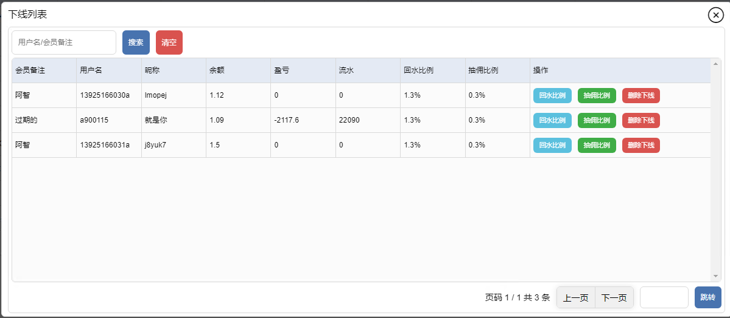



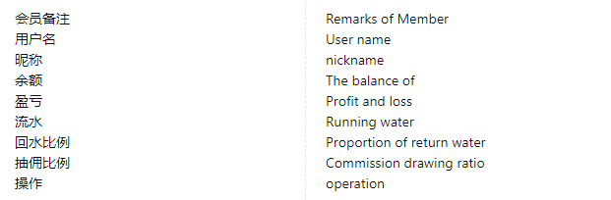

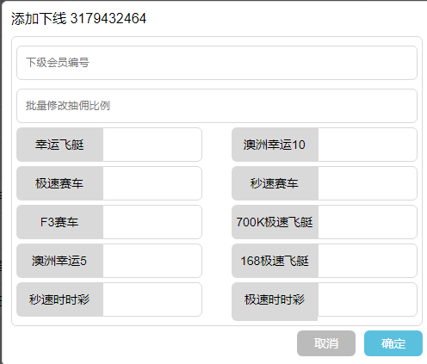

Robot list

